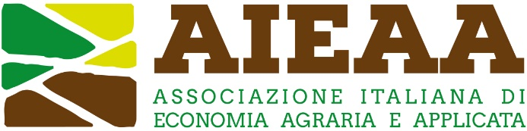

14th Conference of the Italian Association of Agricultural and Applied Economics
18-20 June 2025, Pisa, Italy

Reconciling competitiveness and sustainability in the agrifood system: the role of knowledge and innovation

Proposal of Organized session

Proposer(s): _____________________________________________________ (name and affiliation)

□ Proposed by a scientific association: ____________________________ (name of the association)

□ Proposed by an individual member

Title:
____________________________________________________________________________

Introduction to the topic: (max 500 words)

Paper 1:
- Title:
- Author(s) and affiliation(s):
- Abstract (max 400 words):

Paper 2:
- Title:
- Author(s) and affiliation(s):
- Abstract (max 400 words):

Paper 3:
- Title:
- Author(s) and affiliation(s):
- Abstract (max 400 words):

Paper 4:
- Title:
- Author(s) and affiliation(s):
- Abstract (max 400 words):

