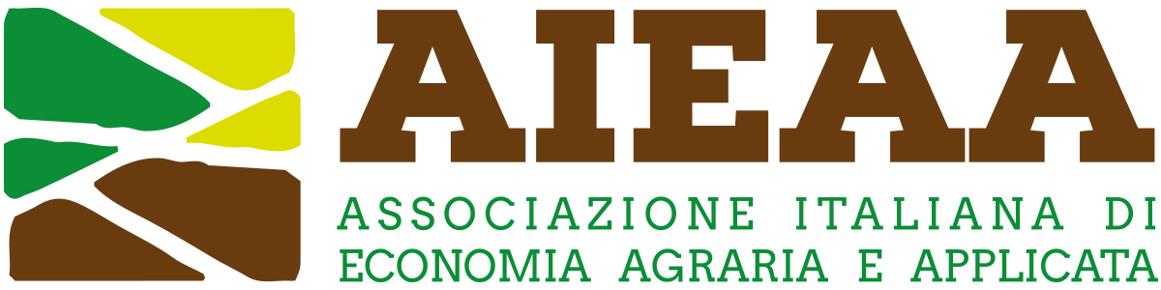

13th Conference of the Italian Association of Agricultural and Applied Economics
20-21 June 2024, Bari, Italy

The social sustainability of European agriculture facing old and new challenges. Issues, methods and policies

Extended abstract
(Contributed paper: minimum 1,500 words; maximum 2,000 words)
(Pitches: maximum 500 words)

Title

Introduction

Data and research methodology

Discussion of results

Main conclusions

Essential references

