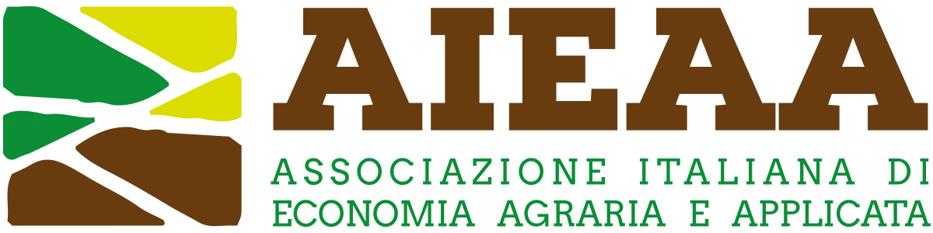

14th Conference of the Italian Association of Agricultural and Applied Economics
18-20 June 2025, Pisa, Italy

Reconciling competitiveness and sustainability in the agrifood system: the role of knowledge and innovation
Extended abstract
(Contributed paper: minimum 1,500 words; maximum 2,000 words)
(Pitches: maximum 500 words)

Title

Introduction

Data and research methodology

Discussion of results

Main conclusions

Essential references

