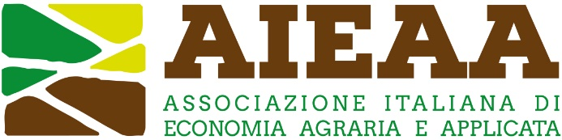

13th Conference of the Italian Association of Agricultural and Applied Economics
20-21 June 2024, Bari, Italy

The social sustainability of European agriculture facing old and new challenges. Issues, methods and policies

Proposal of Panel session

Proposer(s): _____________________________________________________ (name and affiliation)

Title:
____________________________________________________________________________

Introduction to the topic: (max 500 words)

Panelist 1:
- Author: (name and affiliation):
- Short Bio (Scientific profile and/or professional experiences relevant to the panel; max 200 words):

Panelist 2:
- Author: (name and affiliation):
- Short Bio (Scientific profile and/or professional experiences relevant to the panel; max 200 words):

Panelist 3:
- Author: (name and affiliation):
- Short Bio (Scientific profile and/or professional experiences relevant to the panel; max 200 words):

Panelist 4:
- Author: (name and affiliation):
- Short Bio (Scientific profile and/or professional experiences relevant to the panel; max 200 words):

