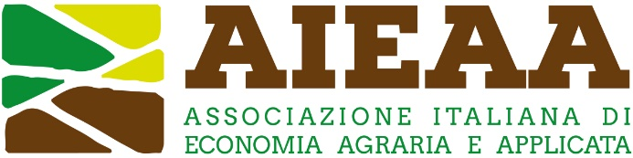

13th Conference of the Italian Association of Agricultural and Applied Economics
20-21 June 2024, Bari, Italy

The social sustainability of European agriculture facing old and new challenges. Issues, methods and policies

Proposal of Organized session

Proposer(s): _____________________________________________________ (name and affiliation)

□ Proposed by a scientific association: ____________________________ (name of the association)

□ Proposed by an individual member

Title:
____________________________________________________________________________

Introduction to the topic: (max 500 words)

Paper 1:
- Title:
- Author(s) and affiliation(s):
- Abstract (max 400 words):

Paper 2:
- Title:
- Author(s) and affiliation(s):
- Abstract (max 400 words):

Paper 3:
- Title:
- Author(s) and affiliation(s):
- Abstract (max 400 words):

Paper 4:
- Title:
- Author(s) and affiliation(s):
- Abstract (max 400 words):

