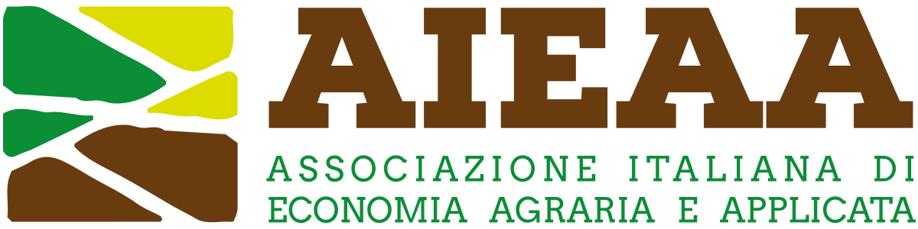

11th AIEAA Conference
16-17 June 2022, University of Tuscia - Viterbo, Italy
CAP, Farm to Fork and Green Deal:
policy coherence, governance, and future challenges.

Organized Session Proposal
(Organized Session: maximum 2,000 words)

Title of the Organized Session
Abstract of the Proposed Organized Session
Organizer
(name and surname, affiliation, contact details)
Author(s) and Abstract of Contribution 1
(name(s) and surname(s), affiliation, contact details and a brief abstract)
Author(s) and Abstract(s) of Contribution 2
(name(s) and surname(s), affiliation, contact details and a brief abstract)
Author(s) and Abstract(s) of Contribution 3
(name(s) and surname(s), affiliation, contact details and a brief abstract)
Author(s) and Abstract(s) of Contribution 4
(name(s) and surname(s), affiliation, contact details and a brief abstract)
Discussant(s)
Please list the name(s) and surname(s), affiliation, contact details of the discussant(s), if any.

