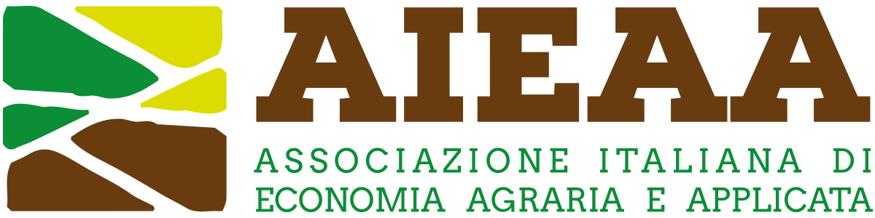

11th Conference of the Italian Association of Agricultural and Applied Economics (AIEAA)
16-17 June 2022 University of Tuscia Viterbo, Italy
CAP, Farm to Fork and Green Deal: policy coherence, governance, and future challenges

Extended abstract
(Contributed paper: minimum 1,500 words; maximum 2,000 words)
(Poster: maximum 500 words)

Title

Introduction

Data and research methodology

Discussion of results

Main conclusions

Essential references

