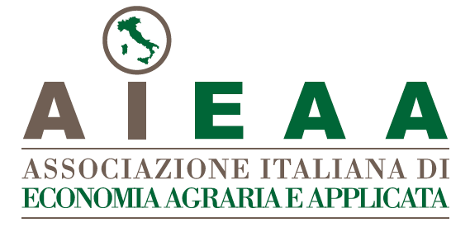
10th Conference of the Italian Association of Agricultural and Applied Economics
9-11 June 2021, Rome, Italy

Agriculture, Food and Global Value Chains:
Issues, Methods and Challenges

Extended abstract
(Contributed paper: minimum 1,500 words; maximum 2,000 words)
(Poster: maximum 500 words)

Title

Introduction

Data and research methodology

Discussion of results

Main conclusions

Essential references

